Task 1

<!DOCTYPE html>

<html lang="en">

  <head>

    <meta charset="UTF-8" />

    <meta name="viewport" content="width=device-width, initial-scale=1.0" />

    <link

      rel="stylesheet"

      href="https://maxcdn.bootstrapcdn.com/bootstrap/4.5.2/css/bootstrap.min.css"

    />

    <title>Document</title>

  </head>

  <body>

    <div class="col-md-4">

      <div class="alert alert-success pt-2">

        <p>Feel Good about bootstrap</p>

      </div>

    </div>

    <div class="col-sm-4">

      <div class="alert alert-primary">

        <p>Feel informed about bootstrap</p>

      </div>

    </div>

    <div class="col-sm-4">

      <div class="alert alert-warning">

        <p>Feel warned about bootstrap</p>

      </div>

    </div>

    <div class="col-sm-4">

      <div class="alert alert-warning">

        <p>Maybe I should read the docs</p>

      </div>

    </div>

    <div class="col-sm-4">

      <div class="alert alert-danger">

        <p>Danger Zone</p>

      </div>

    </div>

    <div class="col-sm-4">

      <div class="alert alert-danger">

        <p>I read the docs</p>

      </div>

    </div>

  </body>

</html>

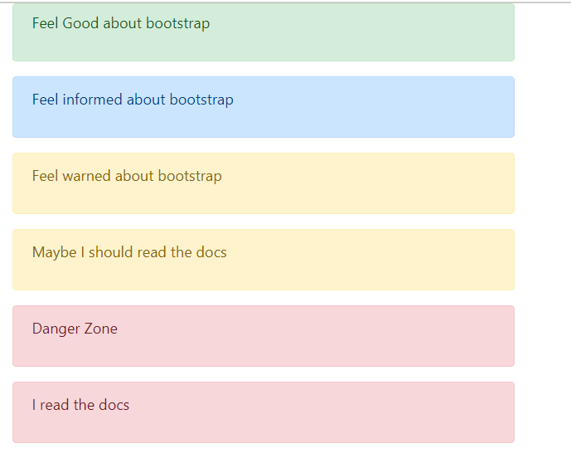

Task 2

<!DOCTYPE html>

<html lang="en">

  <head>

    <meta charset="UTF-8" />

    <meta name="viewport" content="width=device-width, initial-scale=1.0" />

    <link

      rel="stylesheet"

      href="https://stackpath.bootstrapcdn.com/bootstrap/4.3.1/css/bootstrap.min.css"

    />

    <style>

      #result {

        font-family: sans-serif;

        margin-top: 20px;

      }

      .container {

        text-align: center;

      }

    </style>

    <title>Document</title>

  </head>

  <body>

    <div class="container mt-5">

      <button

        class="btn btn-Basic"

        onclick="displayMessage('You clicked on Basic Button')"

      >

        Basic

      </button>

      <button

        class="btn btn-default"

        onclick="displayMessage('You clicked on default Button')"

      >

        Default

      </button>

      <button

        class="btn btn-primary"

        onclick="displayMessage('You clicked on Primary Button')"

      >

        Primary

      </button>

      <button

        class="btn btn-success"

        onclick="displayMessage('You clicked on Success Button')"

      >

        Success

      </button>

      <button

        class="btn btn-info"

        onclick="displayMessage ('You clicked on Link button')"

      >

        info

      </button>

      <button

        class="btn btn-warning"

        onclick="displayMessage('You clicked on warning Button')"

      >

        Warning

      </button>

      <button

        class="btn btn-danger"

        onclick="displayMessage('You clicked on Danger Button')"

      >

        Danger

      </button>

      <button

        class="btn btn-link"

        onclick="displayMessage ('You clicked on Link button')"

      >

        Link

      </button>

    </div>

    <div class="container">

      <div id="result"></div>

    </div>

    <script>

      function displayMessage(*message*) {

        var resultElement = document.getElementById("result");

        resultElement.innerHTML =

          '<div class="alert alert-info" ole="alert">' + message + "</div>";

      }

    </script>

  </body>

</html>

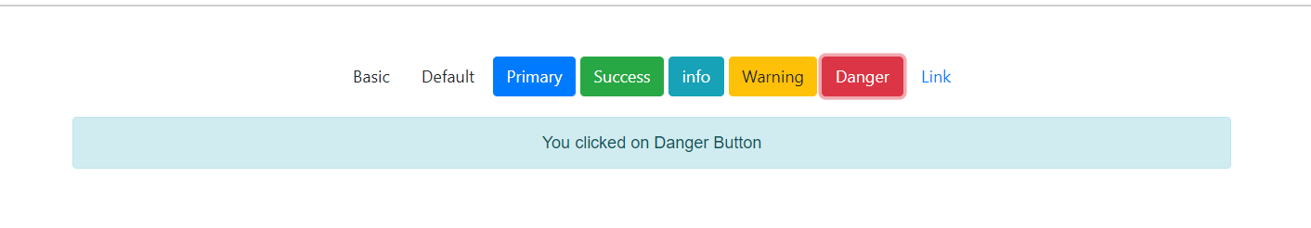

Task 3

<!DOCTYPE html>

<html lang="en">

  <head>

    <meta charset="UTF-8" />

    <meta name="viewport" content="width=device-width, initial-scale=1.0" />

    <title>Document</title>

    <style>

      input,

      button {

        margin: 5px;

      }

    </style>

  </head>

  <body>

    <form id="calculatorForm">

      <label for="num1">Enter number 1:</label>

      <input type="number" id="num1" required />

      <label for="num2">Enter number 2:</label>

      <input type="number" id="num2" required />

      <button type="button" onclick="calculate('add')">Add</button>

      <button type="button" onclick="calculate('subtract')">Subtract</button>

      <button type="button" onclick="calculate('multiply')">Multiply</button>

      <button type="button" onclick="calculate('divide')">Divide</button>

      <div id="result"></div>

    </form>

    <script>

      function calculate(*operation*) {

        let num1 = parseFloat(document.getElementById("num1").value);

        let num2 = parseFloat(document.getElementById("num2").value);

        let resultElement = document.getElementById("result");

        switch (operation) {

          case "add":

            resultElement.textContent = "Result: " + (num1 + num2);

            break;

          case "subtract":

            resultElement.textContent = "Result: " + (num1 - num2);

            break;

          case "multiply":

            resultElement.textContent = "Result: " + num1 \* num2;

            break;

          case "divide":

            if (num2 !== 0) {

              resultElement.textContent = "Result: " + num1 / num2;

            } else {

              resultElement.textContent = "Cannot divide by zero";

            }

            break;

          default:

            resultElement.textContent = "Invalid operation";

            break;

        }

      }

    </script>

  </body>

</html>

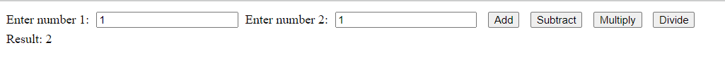

Task 4

<!DOCTYPE html>

<html lang="en">

  <head>

    <meta charset="UTF-8" />

    <meta name="viewport" content="width=device-width, initial-scale=1.0" />

    <title>Document</title>

    <style>

      #result {

        color: red;

        font-weight: bold;

      }

    </style>

  </head>

  <body>

    <form>

      <label for="month">Enter month</label>

      <input type="text" id="month" placeholder="jan, feb, march etc" />

      <input type="button" value="Submit" onclick="days()" />

    </form>

    <p id="result"></p>

    <script>

      function days() {

        let month = document.getElementById("month").value.toLowerCase(); // Convert the input to lowercase for case-insensitivity

        let result = "";

        switch (month) {

          case "jan":

          case "mar":

          case "may":

          case "jul":

          case "aug":

          case "oct":

          case "dec":

            result = "31 days";

            break;

          case "feb":

            result = "28 or 29 days"; // Note: February can have 28 or 29 days

            break;

          case "apr":

          case "jun":

          case "sep":

          case "nov":

            result = "30 days";

            break;

          default:

            result = "Invalid month";

        }

        document.getElementById("result").innerHTML = "Result: " + result;

      }

    </script>

  </body>

</html>

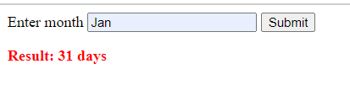

Task 5

<!DOCTYPE html>

<html lang="en">

  <head>

    <meta charset="UTF-8" />

    <meta name="viewport" content="width=device-width, initial-scale=1.0" />

    <title>Document</title>

  </head>

  <body>

    <script>

      function printMultiplicationTable() {

        let number = parseInt(prompt("Enter Table number:"));

        let resultElement = document.getElementById("result");

        let table = "<h4>Multiplication Table for " + number + "</h4><ul>";

        for (var i = 1; i <= 10; i++) {

          table += "<li>" + number + " x " + i + " = " + number \* i + "</li>";

        }

        table += "</ul>";

        resultElement.innerHTML = table;

      }

    </script>

    <button onclick="printMultiplicationTable()">Enter Number</button>

    <div id="result"></div>

  </body>

</html>

